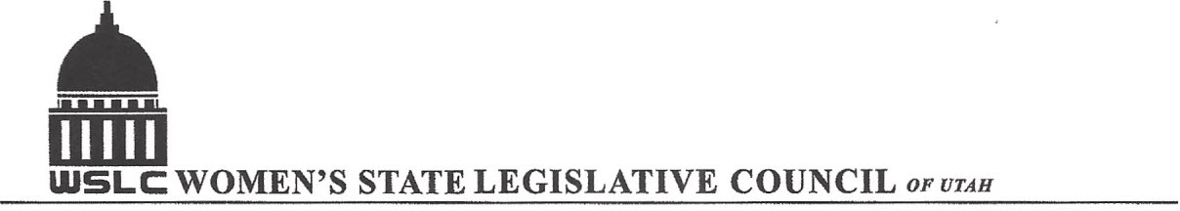
SALT LAKE CITY, UTAH

GENERAL SESSION AGENDA

WEDNESDAY, JANUARY 27, 2016
12PM-1:30 PM COPPER ROOM

12:00 PM CALL TO ORDER/WELCOME: PRESIDENT SHAUNA SCOTT-BELLACCOMO
PLEDGE OF ALLEGIANCE: CHAPLAIN LORAINE TURNER
INSPIRATIONAL THOUGHT
MINUTES: KATIE WITT
TREASURER’S REPORT: RENEE LOWREY
MEMBERSHIP REPORT: PRESIDENT ELECT SUZANNE MULET
UNFINISHED BUSINESS
NEW BUSINESS
PROGRAM UNDER DIRECTION OF JUDICIARY COMMITTEE: TAYLOR ROSECRANS & CATHERINE STOKES
12:15-12:30 PM REP. BRIAN GREENE, SPONSOR CIVIL RIGHTS FORFEITURE, HB 22
12:30-12:45 PM CHAD PLATT, SALT LAKE DISTRICT ATTORNEY’S OFFICE
12:45-1:00 PM REP. NORM THURSTON, SPONSOR WEAPONS ON PUBLIC TRANSPORTATION, HB 67
1:00- 1:15 PM MEMBER OF HOUSE MINORITY CAUCUS
ADJOURN 1:30 PM

ANNOUNCEMENTS: NEXT GENERAL MTG FEB 3, 2016 @COOPER ROOM 12 -1:30 PM UNDER DIRECTION OF EDUCATION COMMITTEE
THANKS TO ALL WHO ASSISTED WITH TODAY’S PROGRAM
TO JOIN WOMEN’S STATE LEGISLATIVE COUNCIL, CONTACT RENEE LOWREY: treasurer@wslcofutah.org
FOR MORE INFORMATION VISIT OUR WEBSITE: www.wslcofutah.org or Facebook page

