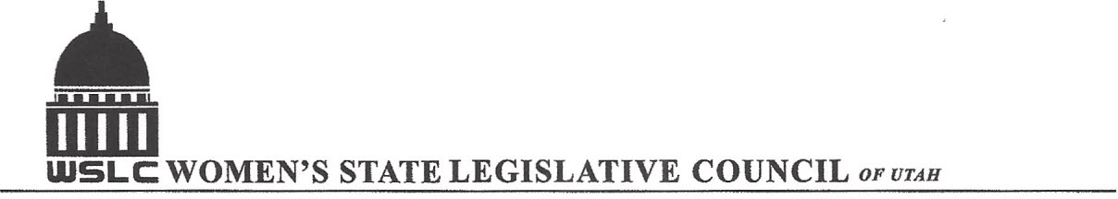
SALT LAKE CITY, UTAH

GENERAL SESSION AGENDA

WEDNESDAY, FEBRUARY 17, 2016
12PM-1:30 PM COPPER ROOM

12:00 PM CALL TO ORDER/WELCOME: PRESIDENT SHAUNA SCOTT-BELLACCOMO
PLEDGE OF ALLEGIANCE: CHAPLAIN LORAINE TURNER
INSPIRATIONAL THOUGHT
MINUTES: KATIE WITT
TREASURER’S REPORT: RENEE LOWREY
MEMBERSHIP REPORT: PRESIDENT ELECT SUZANNE MULET
UNFINISHED BUSINESS
NEW BUSINESS
PROGRAM BY HEALTH & HUMAN SERVICES: KITTY KAPLAN & HEATHER WILLIAMSON
12:15-12:45 PM: SB 73 Medical Cannabis Act, Sen. Mark Madsen (R)
12:45-1:15 PM: SB 89 Medical Cannabidiol Amendments, Rep. Brad Daw (R)
1:15-1:30 PM: RESOLUTION VOTING & DISCUSSION
ADJOURN 1:30 PM
ANNOUNCEMENTS: NEXT GENERAL MTG FEB 24, 2016 @Olmstead ROOM 12 -1:30 PM UNDER DIRECTION OF ENERGY/NATURAL RESOURCES COMMITTEE
THANKS TO ALL WHO ASSISTED WITH TODAY’S PROGRAM

TO JOIN WOMEN’S STATE LEGISLATIVE COUNCIL, CONTACT RENEE LOWREY: treasurer@wslcofutah.org
FOR MORE INFORMATION VISIT OUR WEBSITE: www.wslcofutah.org or Facebook page

