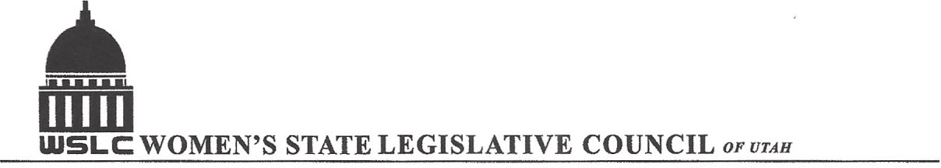
SALT LAKE CITY, UTAH

GENERAL SESSION AGENDA
WEDNESDAY, JANUARY 25, 2017
COPPER ROOM, SENATE BUILDING 12:00-1:30 PM

12:00 PM CALL TO ORDER & WELCOME: PRESIDENT SHAUNA SCOTT-BELLACCOMO
PLEDGE OF ALLEGIANCE: LORRAINE TURNER
MINUTES: KATIE WITT
TREASURER’S REPORT: SHANNON HUFF JACOBS
MEMBERSHIP REPORT: PRESIDENT ELECT SUZANNE MULET
UNFINISHED BUSINESS : REPORT OF NOMINATING COMMITTEE ELECTIONS

12:15 PM FLAG PRESENTATION TO THE FAMILY MEMBERS OF PAST PRESIDENT KAREN THORNE

PROGRAM BY HEALTH AND HUMAN SERVICES COMMITTEES: HEATHER WILLIAMSON & PEG ALDERMAN
12:25-12:40 PM: HB76 End of Life Options Act, Representative Rebecca Chavez-Houck
12:40-12:50 PM: Q&A for Representative Chavez-Houck
12:50-1:05 PM: Con: Laura Bunker, President, United Families International
1:05 - 1:15 PM: Q&A for Ms. Bunker
1:15 - 1:30 PM: SB48 Nurse Licensure Compact, Senator Evan Vickers
1:30 -1:40 PM: Q& A for Senator Vickers
1:40-2:00 PM: SB48 Speaker in Opposition if available
NEW BUSINESS
ADJOURN 2:00 PM

ANNOUNCEMENTS: NEXT GENERAL MEETING IS IN THE COPPER ROOM ON FEB 1st. WE WILL HONOR PAST PRESIDENT ANN DAHL BY PRESENTING HER FAMILY WITH THE UTAH FLAG FLOWN AT THE CAPITOL THAT DAY.
WE MEET EVERY WEDNESDAY DURING THE LEGISLATIVE SESSION JANUARY-MARCH 8, 2017 FOLLOWED BY A LEGISLATIVE WRAP-UP SESSION MARCH 15, 2017. THANKS TO ALL WHO ASSISTED WITH TODAY’S PROGRAM TO JOIN WOMEN’S STATE LEGISLATIVE COUNCIL, CONTACT SUZANNE MULET: treasurer@wslcofutah.org FOR MORE INFORMATION VISIT OUR WEBSITE: www.wslcofutah.org or Facebook page

