HB Arnett’s

“Lite”
hbarnett@fiber.net
801 372 0819

Vol. 37, Issue 6 – July 27, 2018



This Was BYU’s Offense Last Year!

There were too many square pegs trying to fit into a round hole offense. I don’t look for the offense of this season to be much different. It will again be a well-rounded offense, but with a significant difference.

There will be more round peg players with more skills and talent to fit nicely into the offense. Trust me, playmakers make a difference. While the Cougars won’t have SEC playmakers, they will at least have lower tier Pac 12 playmakers and for sure MWC caliber playmakers. It will make a difference.

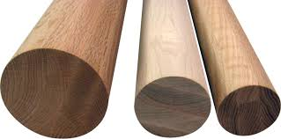

From where are the round pegs coming?

Did Kalani Sitake spend his off season at the lathe of a 9-loss season producing round pegs? He did trim the wood from his coaching tree, but most of his round pegs are showing up because of recruiting, redshirting, redirection and redemption.

I used to have a Church assignment that had me occasionally speaking at Spanish Wards in our stake. I’m sure the talks were mundane, mediocre and just plain malo, but I enjoyed meeting the members and inquiring as to where they came from. It always sounded so exotic.

I’m from Aguas Calientes, they would say. Or Vina del Mar, Topolobampo, Zihuatanejo or Baranquilla. Then I had to tell them that I was from Orem. (Pronounced locally as Awe-rum). It just didn’t have the same rhythmic resonance to it.

My all-time favorite is when they said they were from the city of Chihuahua in the state of Chihuahua…Listen to it. Chi Hua Hua, Chi Hua Hua.

I even love it more now that BYU football has a Chihuahua connection. This guy is an Austin Collie clone and is the ultimate round peg for BYU’s offense this season. I’m talking about incoming freshman Gunner Romney. Read about the connection here Viva Futbol Americano and here Washington Post and The Romneys in Mexico.

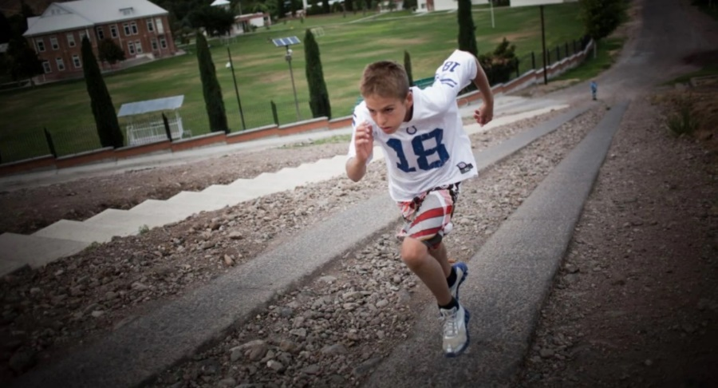
Gunner Romney, 11, trains by running up a large hill in Colonia Juarez, Mexico.

While Romney reminds me of an Austin Collie clone when he was a freshman, Sitake and Jeff Grimes now have two pegs in a pod that weren’t available last season

The second peg that fits perfectly into the offensive scheme is another Collie: Dylan, the youngest of the Collie brothers to play for BYU.

He is a graduate transfer from Hawaii and has made his way back to Provo. He signed with BYU out of high school, went on a mission, played at Hawaii and is now back for his final year of eligibility where he started his college career.

He doesn’t have the size of his older brother, but he does have the hands and “I can catch anything” attitude of Austin. Look for yourself here. Dylan Collie 1 Dylan Collie 2

If Romney pans out like coaches expect him to, they might have to change the fight song to Mariachi music. Here’s a taste of how it Sounds and Looks. Here’s another sound we should get used to, but we will have to see if Greg Wrubell can do this?

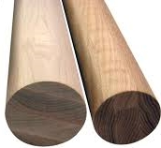
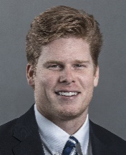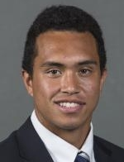

Two More Offensive Pegs and Pass Catchers
Matt Bushman and Moroni Pututau

Now for The Biggest and Most Important Offensive Peg

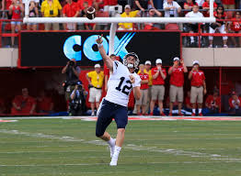
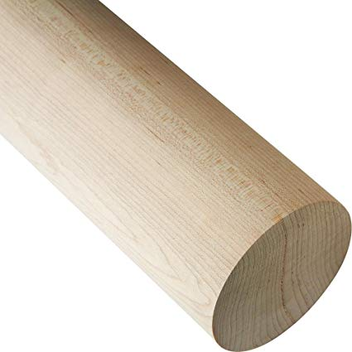

You may want to forget this guy after last year, but don’t.
The season depends on him.

There is no mystery about BYU’s starting quarterback this season: It’s Tanner Mangum

The future at quarterback for BYU will be either Zach Wilson or Jaren Hall. BYU coaches are not stupid. They are not going to jeopardize that future by throwing Wilson to the wolves early against Arizona, California, Wisconsin and Washington. (Just off a mission, Hall won’t be ready to play, but he and Wilson will play at least four games later in the season. That is the competition we should be anxious to see.)

I like Mangum here in this spot. He has shed some pounds and regained confidence. Most importantly, he now has some serious bullets in his gun to whom he can throw the ball and reasonably expect it to be caught.

If for some reason, the Mangum remake doesn’t work out, then you can look for Wilson and Hall to start to see some action. But if that happens, this season will again be a bust and Kalani Sitake will be looking for a bus(t)…the next one out of town.

I don’t see that happening. Mangum wasn’t in the photo below to give it balance. He was as talented as now NFL QB Jameis Winston coming out of high school.

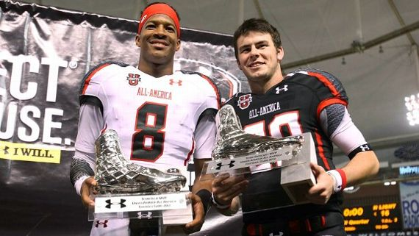

Every quarterback has baggage. Every person on this earth must have their ticket punched at one time or other. Mangum has had his tattered, taken and tossed out the window by most BYU fans.

Don’t count me among them. Call me an extremely early Mangum bandwagon guy and bus rider.

Running Game is Rough at Best

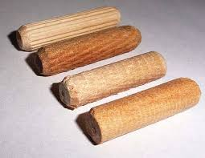
I’m on record as saying that the BYU running game is rough.
So why should we expect it to be better this season? Because defenses won’t be able to load the box this year. With wide outs that can beat press coverage, teams can’t bring their safeties down to shut down the Cougar running game. You can thank wide receiver play makers for an improved BYU running game.

Big and Rough, but still Round


Unless the offense has some big rough, reliable and round offensive linemen, nothing will work. That should describe this offensive line for this coming year. If SEC caliber line coaches like Jeff Grimes and Ryan Pugh can’t get these guys to get it done, then nothing will. Write these names down. Tristin Hoge, Ului Lapuaho, Austin Hoyt, James Empey, Jacob Jimenez, and Thomas Shoaf among others. You won’t remember them, but the improved offense will know their names.

Why aren’t these guys buying a boatload of Putt Partners?

Not sure if they have the golf game, but they certainly have the cash. What’s your excuse?

Taysom Hill Jamaal Williams

Kyle Van Noy Harvey Langi Fred Warner

John Denney Algernon Brown (if he makes 53-man roster) Tejan Koroma (if he makes 53-man roster)

Kai Nacua Bronson Kaufusi

Jordan Cameron I included Cameron here because he lasted one semester as a BYU basketball player before a non-basketball bump in the road with the school derailed his Cougar career. He transferred to Ventura JC, close to his home, played football, transferred to USC, played football for the Trojans and then to the NFL where the pesos are piling high.

Speaking of BYU and Basketball

Dave Rose announced his latest roster for the coming season last week. It’s still not good enough to win an outright WCC regular season or tournament crown. That’s my opinion and I’m sticking to it until Rose proves me wrong. If you are keeping track, the current score is Me: 6 Rose:0.

There will be no future NBA salary cap issues with this roster. And if you haven’t been paying attention, teams that win and make runs in the post season have players that will have salary cap issues.

The closest BYU will come is returned missionary Gavin Baxter. He is athletic enough, so we will see and keep our fingers crossed.

Here’s the roster:

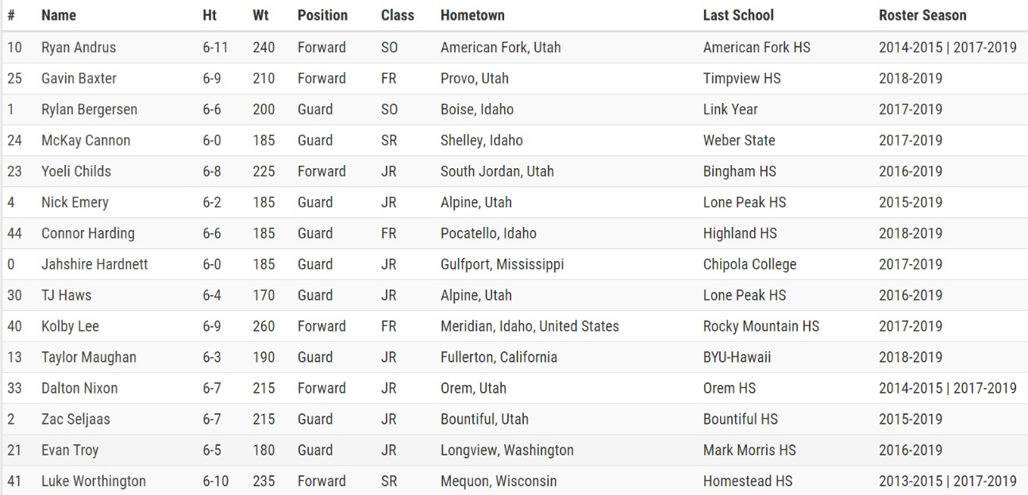

Check out Kolby Lee, #40. Don’t know why they had to clarify that Meridian, Idaho was in the United States. Might be an ICE issue. I spent a few days in Meridian celebrating a birthday. I can vouch that is in the US and that I could see myself living there someday soon. If ICE will allow it.

When I say Frank Bartley, I Think Louisiana-Lafayette….and Pentathlam and Septathlam

Remember Frank Bartley, the former BYU basketball player who transferred back to his home state after his sophomore year in Provo? He became a UL- Lafayette Rajun’ Cajun.

You should also think overall athletic excellence when it comes to select NCAA sports. BYU likes to think they do well in the Director’s Cup annually, but they also do well, along with UL- Lafayette, in the Pentathlam and Septathlam. Read about it here.

I didn’t know about these rankings until just a few days ago. I think I like it better than the Directors Cup standings which Stanford has dominated for two decades or more.

With the Pentathlam and Septathlam rankings and records, it is only about sports that I personally care about and follow. Nothing against field hockey, skiing, skinning dipping and rowing, but sorry I’m not interested, even if your son or daughter is a star in the sport.

COUGAR CLICKS

Francis Bernard to Utah

Former BYU basketball recruit “borrows” ambulance

Jamaal Williams bears testimony

----------------------------------------------------------------
It’s Simple.
Above the line is Free!
Below the line keeps it free when you purchase

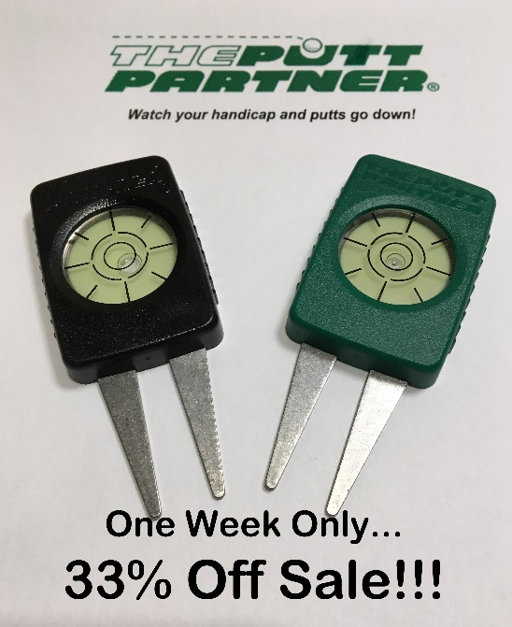

Keep it Free!
Click here to make it happen!

Thanks, your pal, publisher and putt partner in golf and BYU Sports,
HB

